Design Verification – Track Widths

# Section 1: Objective

The objective of this calculation is to determine the minimum acceptable widths of the tracks used to route connections on the printed circuit board (PCB).

# Section 2: References

KiCad (the CAD used for schematic and PCB design) has a built-in calculator for various electrical design considerations. The track width calculator is shown in Figure 1. This is used as one source for equations and as a general guide for which parameters to consider. The equation shown in Figure 1 was verified via various alternate PCB trace width calculators, and the equation shown makes sense according to properties of conductive materials.

* <https://www.4pcb.com/trace-width-calculator.html>
* <https://www.7pcb.com/trace-width-calculator.php>
* <https://www.digikey.ca/en/resources/conversion-calculators/conversion-calculator-pcb-trace-width>

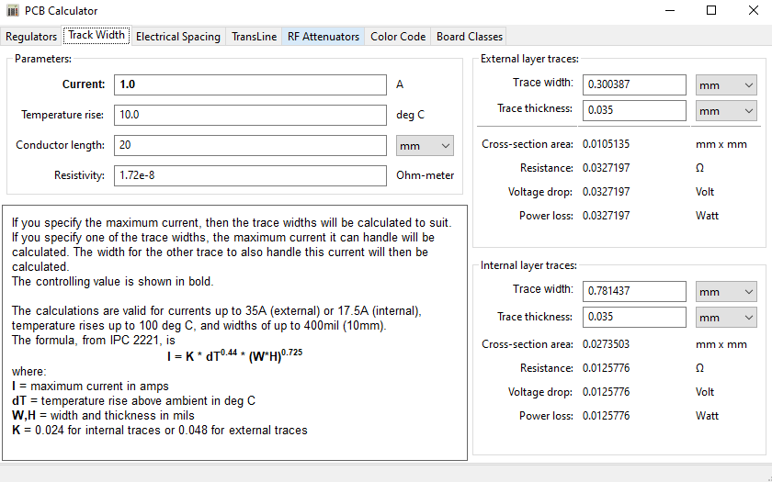Resistivity of copper from a Google search is 0.171 Ohm [mm2/m], which agrees with the value preset in the appropriate field of the above Figure 1.

Figure : KiCad Electrical Calculator: Track Width

Various sources were checked with a Google search, suggesting various maximum human-touch temperatures. The lower limit of these searches was the human body temperature, which is approximately 15 [°C] above ambient, but this assumed continuous touch. Assuming that a person feels heat, the acceptable temperature rise above ambient used in these calculations is 40 [°C], which is roughly half of the temperature rise required to boil water, and people can briefly touch boiling water without pain.

# Section 3: Design Inputs

This is a 2 layer PCB – all traces are on an external layer.

Different components are expected to draw different maximum currents:

* Motors can handle up to 0.35 A continuously (this passes through the motor drivers)
* The Jetson Nano is rated for a maximum current of 5 A (2.5 A to each pin)
  + This goes through the 12 V -> 5 V 91% efficient DC DC converter: 2.3 A is drawn at 12 V
* LED draws 660 mA continuously
* Lengths of the tracks are measured on the PCB layout editor in KiCad.

Some other design inputs had to be assumed and are included in the next section.

# Section 4: Assumptions

If the board is manufactured with 1 [oz] copper per square foot, then the copper thickness is ~35 [μm]. This assumption is visible as “Trace thickness” in Figure 1.

Currents from GPIO pins are negligible since they are digital signals – same goes for anything operating on 3.3 V logic; all power management occurs at 5 V or 12 V in this circuit.

The motor drivers control the current going to the motors but do not change it and therefore have no effect on the current passing through them to go to the motor.

Limit switches have negligible current, even when in the ‘on’ state.

Voltage drops must not exceed 0.5 V to avoid having powered components ‘brown out’ i.e. lose power and regain power, effecting a restart. Typically, brownouts occur at voltages much lower than 0.5 V below rated in a 5 V device, like the Jetson Nano.

# Section 5: Analytical Method and Computations

Currents and lengths are updated into the Track width calculator visible in Figure 1. The currents expected along each trace are known by Kirchoff’s Current Law and the loads that must be supplied power, and lengths are measured in CAD. Notice that the length has no impact on the calculations for trace width, but rather affects the resistance of the trace and therefore the corresponding voltage drop along the trace.

# Section 6: Calculations

There is one trace less than 3 mm long that goes to all three motors and the LED, for a maximum total continuous current of $3*0.35+0.66=1.71 A$, corresponding to an external layer trace width of 0.27 mm and an acceptably low voltage drop of 0.0093 V.

From there, the LED branches off and the remaining trace carries $3*0.35=1.05 A$ to the motors, and therefore the external layer trace width must be at least 0.14 mm, which is smaller than the default track width in KiCad of 0.25 mm, so the default will be used. When the traces to the three motors branch off, the required trace widths will be even lower since each current only draws 0.35 A, so the default trace width is used for those as well. [VOLTAGE DROP]

The Jetson is powered by 5 A along a track length of 81 mm. The minimum track width is 1.19 mm, and the associated voltage drop is 0.167 V, which is acceptable.

The 5 A going to the Jetson Nano is from the DC DC converter. Since it has a minimum efficiency transforming 12 VDC to 5 VDC of 91%, the power that must be supplied on the input is $P_{in}=\frac{5V*5A}{0.91}=\frac{25W}{0.91}=27.5 W$. Therefore, the current supplied at 12 V is $I_{in}=\frac{P_{in}}{V_{in}}=\frac{27.5}{12}=2.29 A$, corresponding to a minimum trace width of 0.41 mm. This is along a 20 mm long trace, therefore leading to an acceptable voltage drop of 0.055 V, which barely changes the 12 V input to the DC DC converter.

The default trace width is used for all digital logic traces.

# Section 7: Results/Conclusions

All of the above-calculated trace widths are implemented on the printed circuit board, and the voltage drops due to resistance in the traces are acceptable for full operation of all electronic parts.